Advanced Process Control - Industry Trends and Market Growth
Introduction
Advanced Process Control (APC) in the form of linear model predictive control (MPC) has existed for more than 40 years. In that time the core algorithms have remained largely unchanged although user interface and model development tools have evolved significantly. By far the most prolific users are still in the oil and gas and petrochemicals industry where APC is a standard expectation in peer-ranked assessments like Solomon. But some key drivers like rising energy costs, sustainability and Industry 4.0 have created a renewed interest in this mature technology. The APC market is showing signs of healthy growth and many new market sectors will benefit from the deployment of this well-proven and tested technology.
Energy Efficiency and Industrial Sustainability
APC projects on refining and petrochemical units can deliver impressive benefits and short ROI from increased production and increased yield of high-margin products. These types of projects account for a significant proportion of current APC installations. But increased energy costs along with energy transition and net zero emission operations put more focus on the use of APC for energy reduction. Any processes that are consuming hydrocarbons for power or steam generation, process heating or product drying can likely benefit from APC. Heat rate reduction on a fired heater through APC can deliver a project payback in a few months at current energy prices.
Many industrial operations undergo significant fluctuations in energy consumption due to dynamic operating conditions, equipment degradation, market volatility, and suboptimal control strategies. Even digitally literate companies often rely on the analysis of historical performance data for efficiency improvements and only implement corrective actions retrospectively. APC provides the ability to accurately measure, monitor, predict and control energy usage in real-time and can play an important role in meeting the sustainability goals and objectives of asset owners.
New Market Sectors
The drive for improved operating efficiency and productivity, and increased awareness through digitalisation and industry 4.0 initiatives will all lead to renewed interest and adoption of APC in new industry sectors like mining, food and beverage, renewables and pharmaceuticals. Traditional APC users like oil and gas will extend into upstream operations which do not have the APC coverage seen in downstream operations. All of these sectors will benefit from a scalable, easy-to-deploy approach. Some traditional APC suppliers may be challenged in pivoting their technologies into these new sectors, opening up opportunities for new entrants.
- Renewable Energy: The increased deployment of renewable power generation creates new challenges in managing the use of available assets subject to varying grid tariffs, demand and generating capacity. APC can be used to plan and optimize renewable energy generation, such as wind and solar power, make optimal use of available energy storage capacity and improve overall efficiency.
- Mining and Metals: A goal of the mining and metals industry is to deliver minerals to the market at the lowest possible cost per unit. Transforming raw materials from ore into a saleable product involves crushing and milling, along with physical and chemical separation using high-cost-to-operate industrial equipment. APC can help optimise these processes by lowering operating energy and maximising the throughput of the installed equipment which are major objectives in lowering unit costs.
- Food and Beverage: Many operations like evaporation and drying are energy intensive and expensive to operate, they will benefit from improved efficiencies offered by APC.
- Water and Wastewater Treatment: APC can be used to optimize water treatment processes, such as desalination and wastewater treatment, and ensure consistent water quality and availability.
- Pharmaceuticals: Opportunities for the biopharmaceutical industry include improved production throughput, faster time to market for new products and lower production costs. APC can reduce product variability, and improve product quality and consistency.
As technology continues to advance and new challenges emerge, we can expect to see APC being adopted in even more market sectors.
Scalable APC Solutions
Some of the large-scale multi-unit APC applications that were deployed over the past few decades have proven difficult to maintain, and lack of support has led to degraded service factors and performance. To better manage their risk, many end users are now looking to implement smaller, more scalable, APC projects across a wider variety of process applications.
Agile Project Management
Agile project management is a flexible and iterative approach to project management that emphasizes the continuous delivery of small, incremental changes and collaboration among team members. An agile approach to APC deployment means breaking the project down into smaller, more manageable pieces and developing and testing control strategies in short iterations. This allows the project team to identify issues as they arise and make adjustments based on feedback from stakeholders and data analysis.
Optimal Use of Scarce Engineering Resources
As APC experts have progressed up the career ladder or retired, many companies are finding it difficult to find replacements. This skills shortage heightens the need for improved APC technology that is easier to deploy and has a shorter time to value. The future success of APC will be through solutions that provide the lowest deployment risk coupled with unsupervised model update capabilities.
Beyond Traditional APC
Linear model predictive control (MPC) has dominated the APC market since the 1980s and will continue to be the most commonly used form of APC. But some emerging technologies like non-linear MPC and economic MPC will open up new application opportunities. Economic MPC is a control strategy that combines the principles of economic optimisation and model predictive control. The dynamic solution is optimised over an extended time horizon which makes it suitable for applications that require resource planning over a fixed period (e.g. day or week), especially where costs and availability are expected to fluctuate. Examples include optimising the operation of electrical equipment subject to varying electricity tariffs or managing a mix of renewable and conventional power generation and storage units within a microgrid.
Plant Wide Optimisation
The need for integrated plant-wide optimisation still exists and this function will be filled by a higher-level real-time optimisation (RTO) layer built on a foundation of APC applications. The APC will drive the process to the optimal targets calculated by the RTO. The RTO will perform the function of linking planning and scheduling tasks with the APC layer and orchestrating the base layer APC applications.
Edge Control
Rather than the server-grade hardware stacks that are required for typical large-scale multi-unit APC applications, a scalable approach can make use of distributed hardware with a smaller footprint and much lower cost of ownership. Deploying APC on edge devices like PLCs and PACs enables advanced control within the standard control layer (ISA95 Level 1). These edge devices can be located in the field and maintained by automation systems personnel. As well as opening up the potential for a new range of APC applications, deployment on these types of edge control hardware has the advantage of significantly lowering the cost and skill set required for implementation and maintenance. Edge deployment is a step towards the goal of bringing APC into the standard toolkit of the practising control engineer.
Open Process Automation (OPA)
The goal of the Open Process Automation Forum is to create a standards-based, open, secure, and interoperable industrial process control architecture. A key advantage of this architecture is its ability to support modular, plug-and-play systems that can be easily upgraded or replaced without disrupting the entire system. Creating an open environment in which anyone can develop applications will greatly expand the offerings for advanced control applications and data analytics, which will drive value capture.
Recognizing the reluctance of risk-averse process industry users to adopt new automation technology, the Open Process Automation Standard includes many existing industry standards. For example, at the control and IO level, distributed control nodes (DCNs) run IEC 61131 or IEC 61499 control applications and communicate with the rest of the system using a connectivity framework based on OPC-UA. HMI and other computing applications are run on the Advanced Computing Platform (ACP). An ACP can perform many types of computing including function block execution, analytics, and optimisation and is hosted on industrial server hardware.
Within this architecture, APC solutions can be deployed in the ACP provided that the software supplier can support containerised deployment. The industry standards supported in the DCN also permit the deployment of APC function blocks that implement either the IEC 61131 or IEC 61499 standard. This opens up the potential for a new APC paradigm that can be deployed on a range of compliant hardware as a core component of the control function (ISA95 Level 1) rather than at a supervisory level (ISA95 Level 2). APC in the DCN will be simple to deploy and distribute and maintain within the plant control system. Deployment at the control layer will enable support for higher integrity solutions with fast scan intervals like a fired heater or compressor, it also introduces completely new opportunities in applications like industrial robotics and discrete manufacturing.
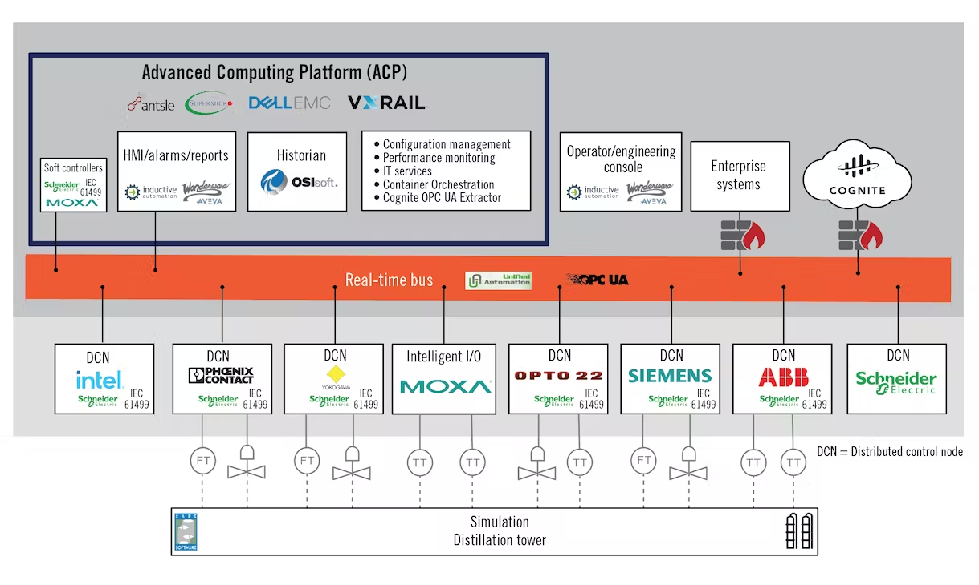
Figure 1 The ExxonMobil OPA Test Lab (Source: ExxonMobil)
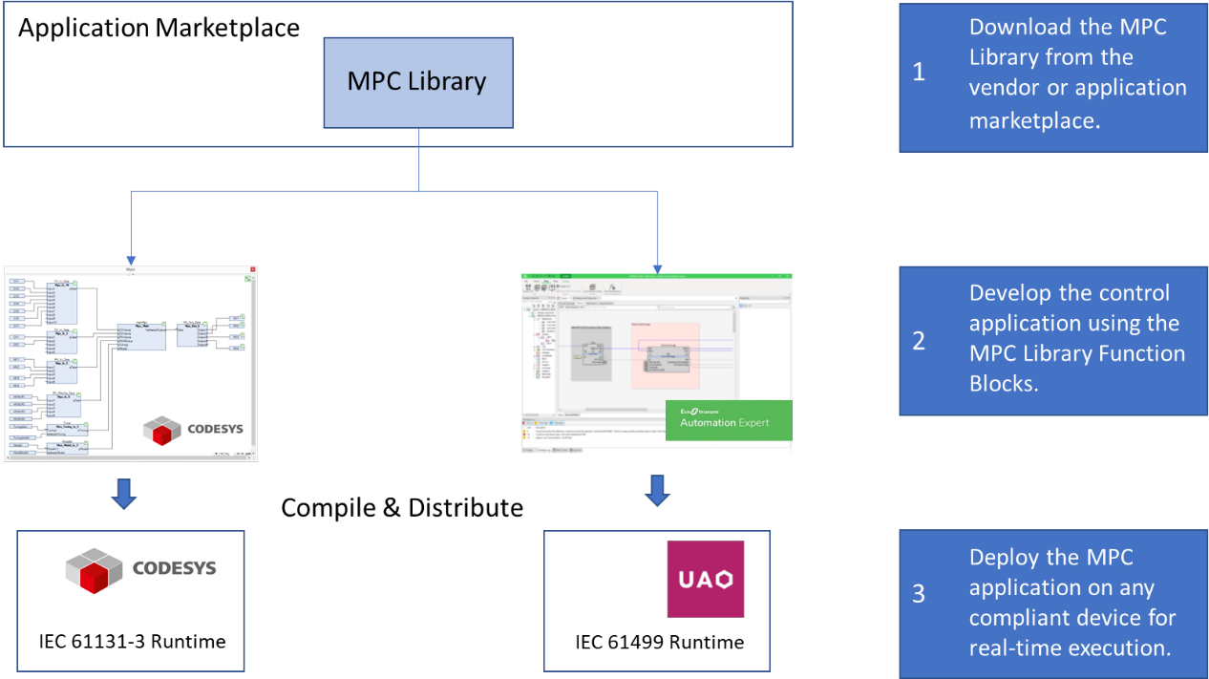
Figure 2 MPC Deployment in OPA
Market Size and Growth Rate
Based on a selection of published reports, the current APC market has a value in the range of USD 12 - 18 billion with a compound annual growth rate (CAGR) in the range of 6.3 - 12.9%. Growth is attributed to the demand for energy-efficient production processes, the growing need for reducing operational costs, and the rising adoption of Industry 4.0 technologies.
Key Players
With the merger of AspenTech and Emerson's industrial software businesses and Schneider Electric completing their acquisition of AVEVA all of the major APC software providers are now linked to industrial automation companies. Despite these moves, the list of major APC suppliers has not changed significantly in the past few decades. Some of these products and their underlying algorithms have remained largely unchanged in that period and these vendors may be challenged to adapt their solutions to match evolving customer needs.
- AspenTech
- Honeywell
- Yokogawa
- Rockwell Automation
- AVEVA
- ABB
Conclusions
Some key drivers like high energy costs, sustainability, digitalisation and Industry 4.0 have generated renewed interest in APC. Learning lessons from the past, successful APC projects will follow a more agile approach, iterative deployment of smaller applications and minimal time to benefit. The scarcity of skilled resources puts more emphasis on robust control solutions with high service factors and easily maintainable and adaptable models. The new wave of applications will most likely include sectors with relatively low historical coverage like pharmaceuticals, mining, and food and beverage, and new sectors like renewables. The oil and gas sector will extend its deployment upstream as well as in net zero and energy transition initiatives. Although linear MPC will remain dominant, some new variants like non-linear MPC and economic MPC are also emerging. The need for plant-wide optimisation and integration with planning and scheduling functions will be filled by RTO solutions that are still reliant on a foundation layer of APC applications.
All of this means that the APC market will continue to show healthy growth with a high single-digit or possibly double-digit CAGR. Although the existing incumbents are likely to be well-placed to benefit from this growth there is potential for displacement by a player that is better equipped to adapt to the evolving landscape.
About Spiro Control
Spiro Control’s digital solutions provide deep insight into process performance, enabling operators to optimise their operations in real time. The result is lower energy consumption and emissions and improved operating margins. We build technology that is easy to use and maintain, delivering robust solutions capable of tackling complex applications. Our continuous investment in R&D helps us to stay innovative and to develop products that meet our industry customers’ needs.
Spiro’s range of process optimisation and advanced control products include Spiro Dynamic RTO, Spiro Digital Twin, Spiro MPC and Spiro PID. Spiro MPC is the only model predictive control technology deployable as a standard IEC 61131 function block inside the OPA architecture. Our patented distributed cooperative control technology enables cooperation between MPC applications deployed within distributed architectures like IEC 61499.
Our application engineers have many decades of combined experience in the design and deployment of APC and RTO solutions across a wide range of industries and technologies. Combining our proven software development capability with our process knowledge and optimisation expertise, we can achieve high-quality solutions for our clients, delivering superior performance at a competitive cost.

